Hello!

Thanks for helping out in taking notes!

The talks are organised per stream, so you can find them in the appropriate folder:

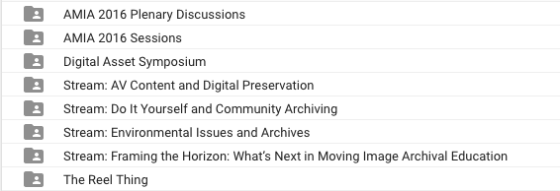

The AMIA 2016 Sessions folder contains the sessions that do not belong to any stream or event (DAS or The Reel Thing), organised by day.

You can easily navigate every document by using the Google Docs Document Outline functionality (from the menu: *Tools > Document Outline*) or just use search.

Every document is organised as follows:

|  |  |
| --- | --- |
| *Session Title* Session date  Chair: Name | |
| Speaker 1 Sara chapman Speaker 2 <feel free to type away here, too>  <and below, if you like!> | |

If you like credits and eternal gratitude, feel free to drop in your name on top of the document!

Questions? Check in with:

For the Conference Online Task Force: Erwin Verbruggen <[everbruggen@beeldengeluid.nl](mailto:everbruggen@beeldengeluid.nl)> @[erwinverb](http://twitter.com/erwinverb)

For the AMIA Education Committee: <[amiaeducationcommittee@gmail.com](mailto:amiaeducationcommittee@gmail.com)>